Syeda Reeha Quasar

14114802719

4C7

Aim

Write a program to find the sum of two numbers declared in a class and display the numbers and sum using friend class.

Experiment - 10

Object Oriented Programming Lab

# **EXPERIMENT – 10**

## **Aim:**

Write a program to find the sum of two numbers declared in a class and display the numbers and sum using friend class.

## **Source Code:**

#include <iostream>

using namespace std;

class twoNum{

    private:

        int a, b;

    public:

        void input(){

           cout << "Enter 2 numbers: ";

           cin >> a >> b;

        }

        friend void sum(twoNum t);

};

void sum(twoNum t){

    cout << "First number is: " << t.a << endl;

    cout << "Second number is: " << t.b << endl;

    cout << "Sum of these numbers is " << t.a + t.b << endl;

}

int main(){

    twoNum t;

    t.input();

    sum(t);

    return 0;

}

## **Output:**

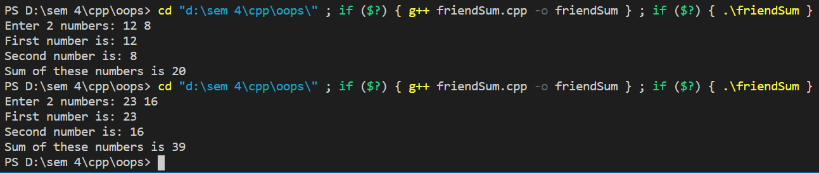

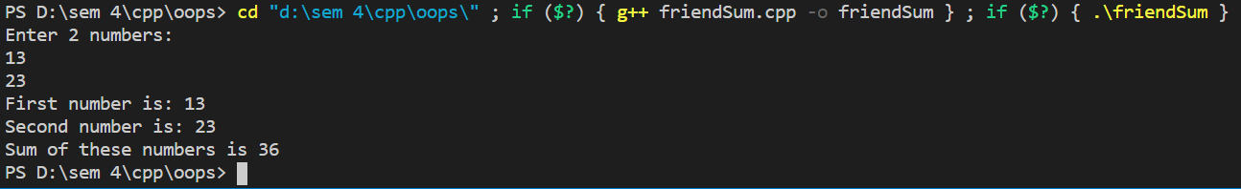

# Viva Questions

Q1. What are the benefits of friend function?  
Ans.

* A friend function is used to access the non-public members of a class.
* It allows to generate more efficient code.
* It provides additional functionality which is not normally used by the class.
* It allows to share private class information by a non member function.
* It is used when two or more classes may contain members that are interrelated relative to others parts of the program.

### Q2. What are disadvantages of friend function?

Ans.

* A derived class does not inherit friend function.
* Friend functions can not have a storage class specifier i.e they can not be declared as static or extern.